Experiment 4: Vacuum Cleaner Problem
Aim
To simulate the Vacuum Cleaner problem using Python.
Objective
To clean all dirty rooms automatically.
Algorithm
- Check each room.
- If dirty, clean it.
- Move to the next room.
- Repeat until all rooms are clean.
Flowchart
Start
|
Check Room
|
Dirty?
/ \
Yes No
| |
Clean Move
\ /
Next Room
|
All Clean?
|
Stop
Code and Output
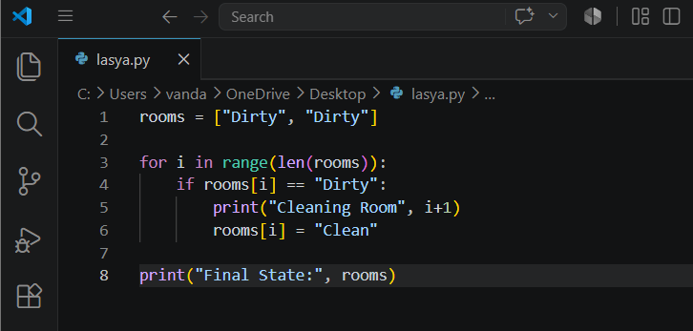-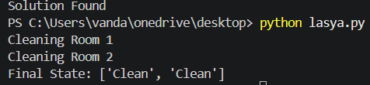
Result
All rooms were cleaned successfully.
Conclusion
The Vacuum Cleaner agent cleaned every dirty room automatically.

